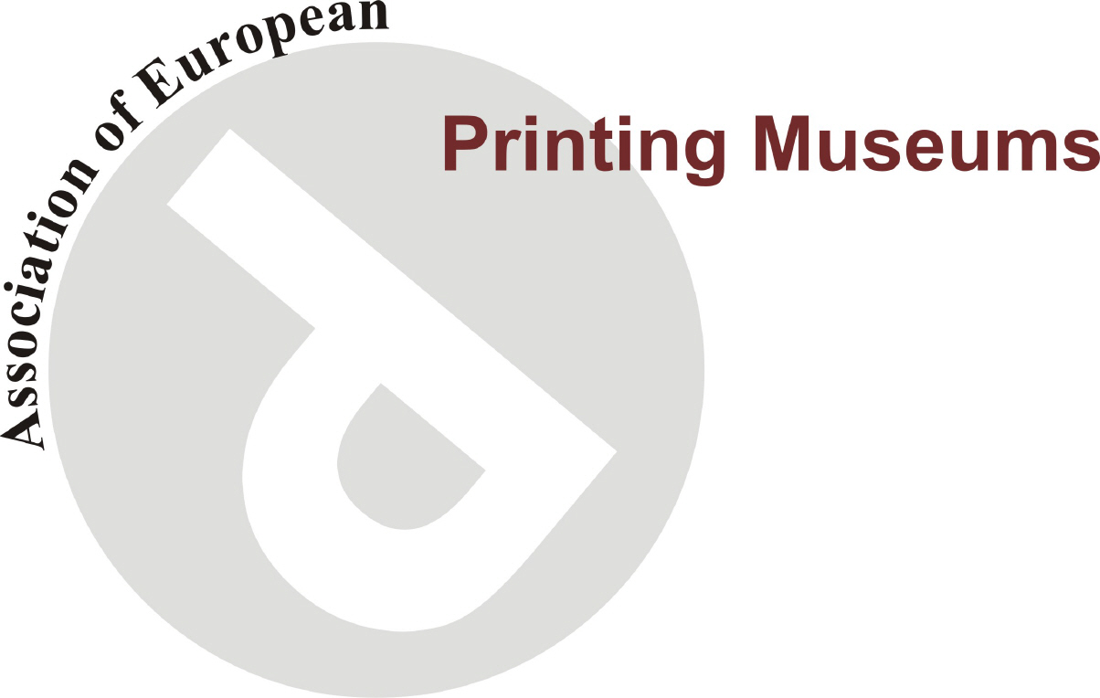
Association of European Printing Museums (AEPM)

Symposium
The stuff of Printing
Thursday 5th – Friday September 6th 2013 Bristol, UK

Thursday 5th September
Traders Café, Bower Ashton Campus, Kennel Lodge rd, Bristol BS3 2JT

9.30 am Coffee and registration,

10 am Welcome to Bower Ashton and the Centre for Fine Print Research.
AEPM President Alan Marshall, Prof Stephen Hoskins (Room 3B1)

10.15 am Creating traditional inks from dry powder pigment for Artists, Printmakers and Letterpress. Michael Craine (Cranfield Colours).
11 am The Baskerville Project. Dr Caroline Archer,U(niversity of Central England, Birmingham)
11.45 am Mould Made and Hand Made Papers. John Purcell (John Purcell Paper Ltd ) and Steve Caroll (St Cuthberts Mill)
12.30 pm Lunch
Bower Ashton Traders

2 pm AEPM presentations
Jeungdoga moveable type : the oldest known metal printing types? Prof. Kwon-Heui Nam, Kyungpook National University, Korea
3.00 pm The Penguin Books Archive in Bristol Prof. Phil Baines (Central St Martins college of art and design, London),
3.45 pm Tea

4pm Traditional Underglaze Tissue Printing from an Engraved Copper Plate for Ceramics. Stephen Hoskins

8 pm Dinner At Goldbrick House, Park Street, Bristol City Centre.

Friday 6th September
9.30 am Coffee,
Traders Café, Bower Ashton Campus, Kennel Lodge rd, Bristol BS3 2JT

10 am AEPM Annual General Meeting
(Guided tours of the CFPR for non-attendees of the AGM)

12 pm Lunch
Traders Bower Ashton

1 pm Coach to Cranfield Colours, CwmBran, Wales,

4pm Coach returns to Bristol (via Bristol International and Bristol Temple Meads Railway Station)

Symposium ends.
Delegates can book and pay for a place online via our online Store.
http://store.uwe.ac.uk/browse

